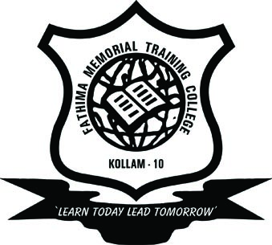
FATHIMA MEMORIAL TRAINING COLLEGE
PALLIMUKKU,KOLLAM
Accredited by NAAC with ‘A’ Grade

SECOND SEMESTER M.ED DEGREE MODEL EXAMINATION NOVEMBER 2024
Dates | Name of Subject
28-11-2024 | PCS 2 Advanced Educational Psychology
04-12-2024 | Fundamentals of Educational Research and Statistics
06-12-2024 | Sec./Sr. Secondary Education : Curriculum & Mangement

28-

